1. Login in Admin Portal
2. Services --> Click Manage Security

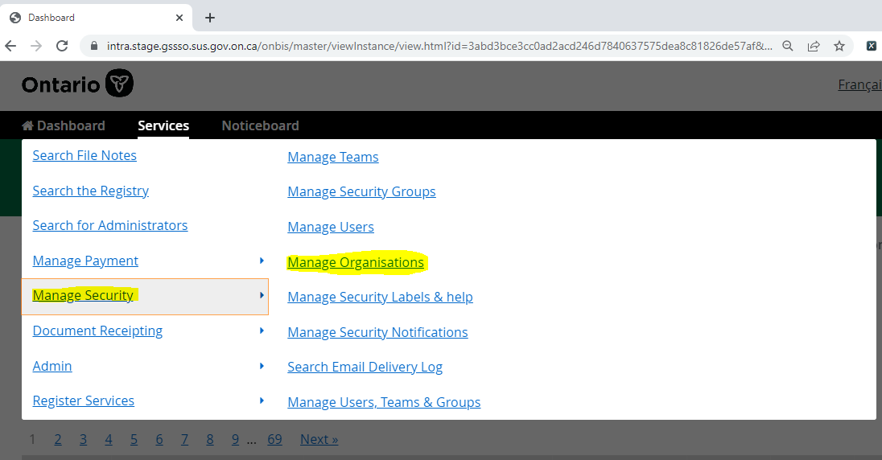

1. Click Manage Organizations --> Create Organization

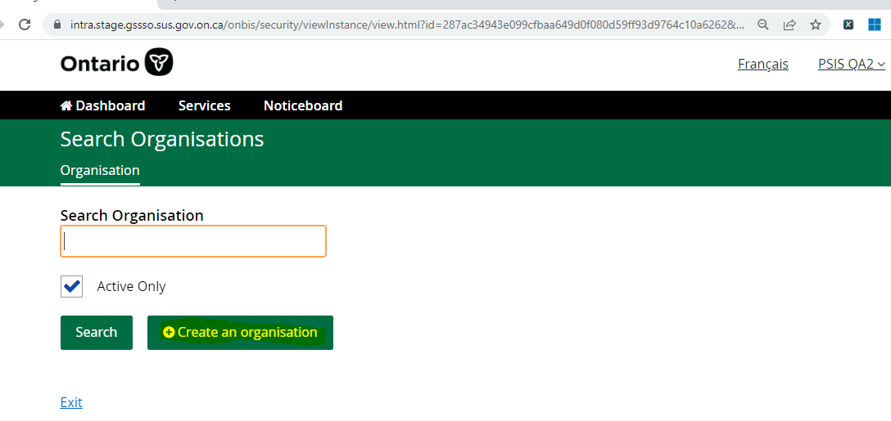

1. Enter Organization name,Category,Permissions,contact Email Address,Confirm Email Address details

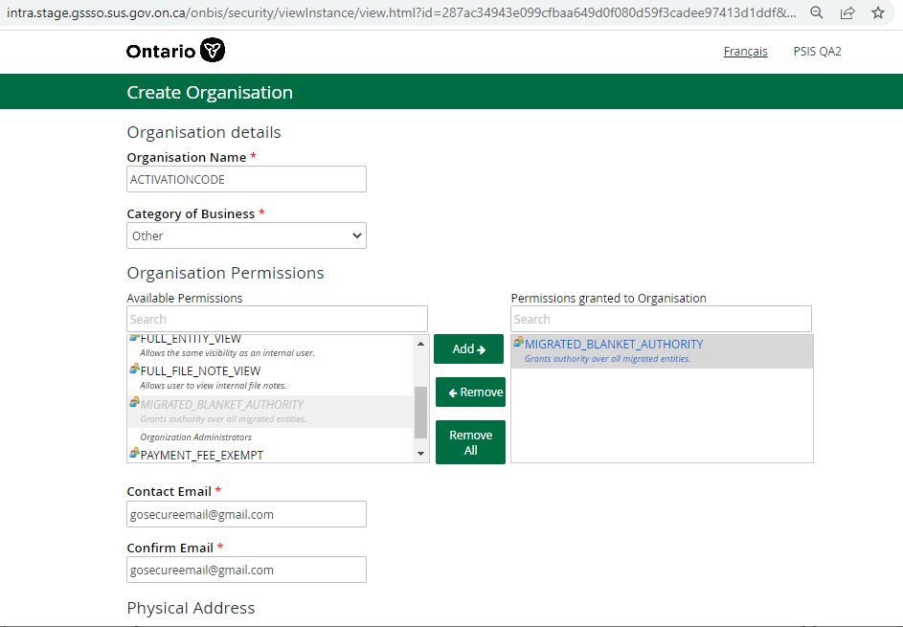

1. Enter Canadian Postal Address -->Click Find Address button

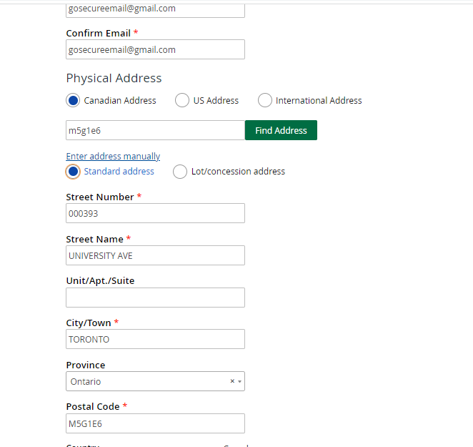

1. Enter Organization Administrator First Name, Last Name, Email Address & Confirm Email address details.

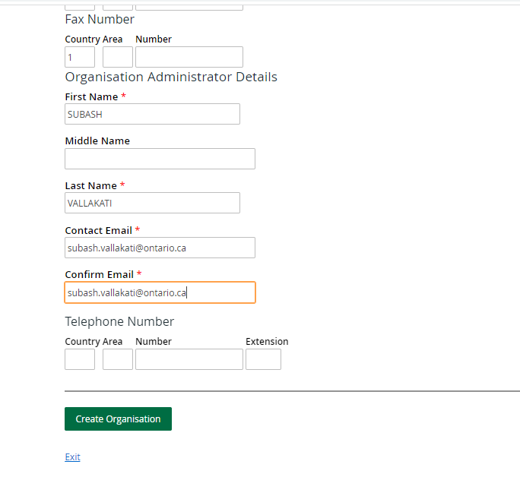

1. Click Create Organization --> Activation Code will be sent to registered email address

